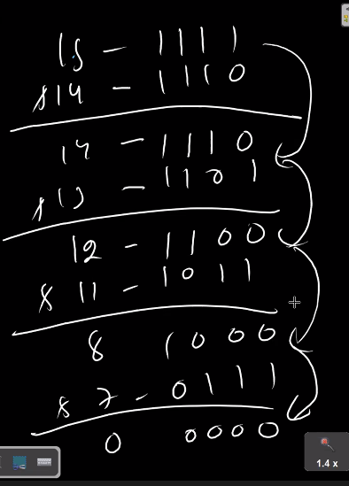



**78,169,371**

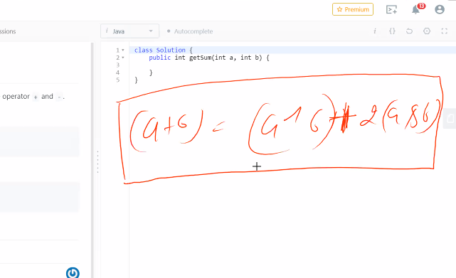

**Zomato nucleus swiggy ,Samsung ssr ,airtel xlab, sap labs-israel**